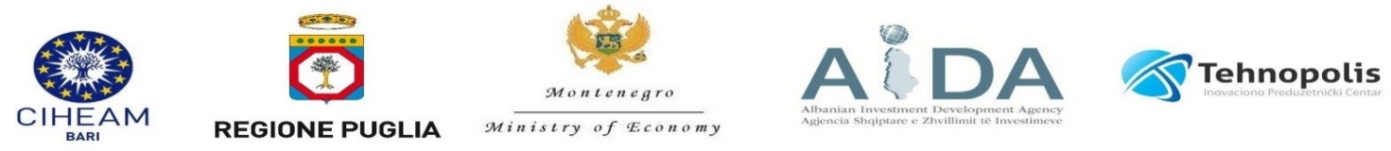
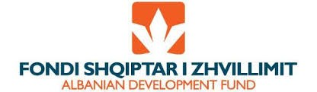
FILA Project

Strengthening and empowering of cross border innovation networks through Fertilization Innovation Labs in Agro-food for improving the connection between research and SMEs (EIP approach)
Cross border meeting to sign the agreement
D.T3.1.1
19 November 2019, Tirana
Hotel Plaza Tirana

The objective of the cross-border meeting is sharing the network agreement between the FILA project partners, aimed at defining the priority objectives, the strategy and actions that should be taken in the three FILA Lab. The agreement will be signed at a later time.
During the meeting project partners will start a discussion on a policy paper draft related to the possible measures in the cooperation area to improve technology transfer processes, exploit the results of the research and cooperation between research organizations and companies in the agri-food sector. The policy paper takes into account both the FILA project results, the experience in the application of the EIP AGRI approach at European level, and the analysis of policies for innovation and technology transfer in the agri-food sector implemented both in the cooperation area and in the other geographical contexts at international level.
13:30 -- Networking lunch at Hotel Plaza Tirana
15:00 Welcome speech – AIDA, Mrs. Dilfirus Vrioni, Director of Marketing, Research and Analysis Directorate
15:15 -- Presentation of the FILA network draft agreement – CIHEAM Bari
15:45-- Policies and measure of the Knowledge transfer system and European innovation partnership in agriculture in Europe: experience in Puglia Region – CIHEAM Bari / Apulia Region
16:00 Policies and measure of the Knowledge transfer system in agrifood in Albania ADF / AIDA
16:15 Policies and measure of the Knowledge transfer system in agrifood in Montenegro Tehnopolis / MEK
16:30 Discussion of the FILA network draft agreement and definition of methodology to elaborate and share of the policy paper on knowledge transfer in agri-food sector.

